**System Testing**

1.1 Definition of Software Testing

Software testing is the use of test tools to test the function of product according to the test plan and process, and even write different test tools as needed, design and maintain the test system, analyze and evaluate the problems that may occur in the test plan. After executing the test case, you need to track the failure to ensure that the product you are developing is suitable for your needs.

Software testing is the final review of software requirements analysis, design specification and coding implementation before the software is put into operation. It is a key step in software quality assurance.

1.2 Purpose of Software Testing

Testing is the execution of a program and the purpose of testing is to find the error. The correctness of the program cannot be proved unless only a limited number of cases are handled. Checking whether the system meets the requirements is also the desired goal of the test. A good test case is to find errors that have not been discovered and a successful test is to find the wrong test.

1.3 Software Testing Method

Software testing techniques have different classifications according to different methods: static testing, dynamic testing, black box testing, white box testing; unit testing, integration testing, regression testing, system testing, verification testing, and validation testing.

1.4 Functional module test

1.4.1 File upload function test

(1) Click the Upload button and Select File dialog box popup, and then select the file.

Figure 1.1 Select the upload File

(2) After the upload is completed, website prompts that upload is successful, as shown in

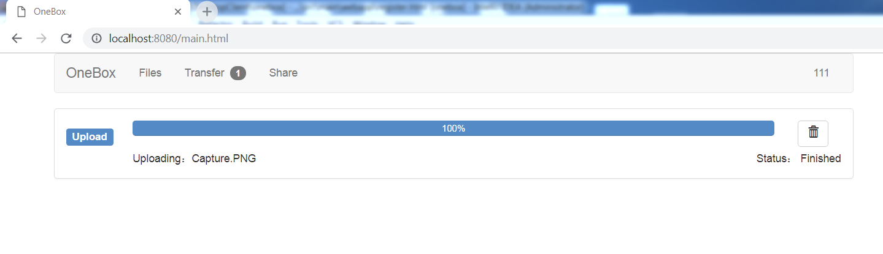

Figure 1.2 Upload completed

1.4.2 File Download Function Test

(1) Right-click on the file in the file list and select Download in the middle of the pop-up menu. See Figures 1.3and 1.4.

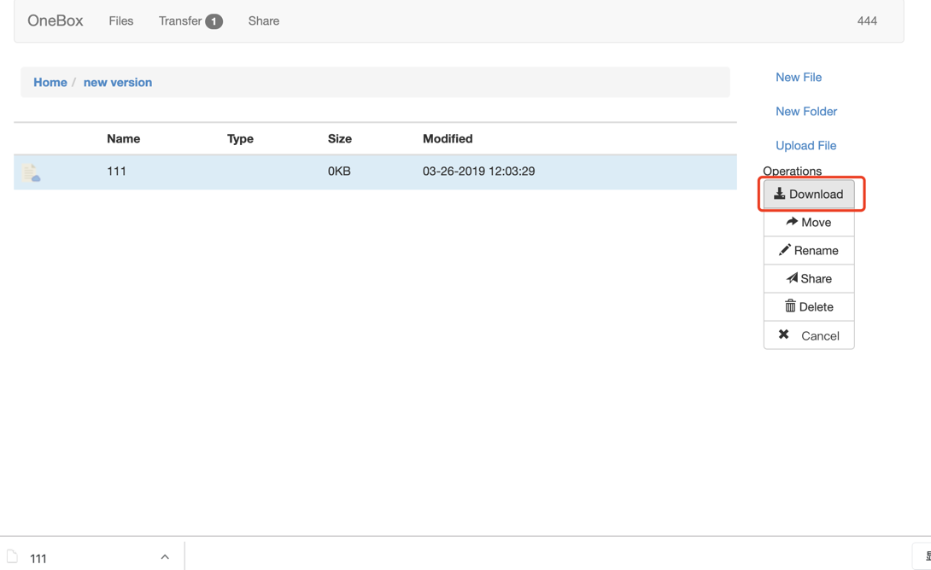

Figure 1.3 Click download button

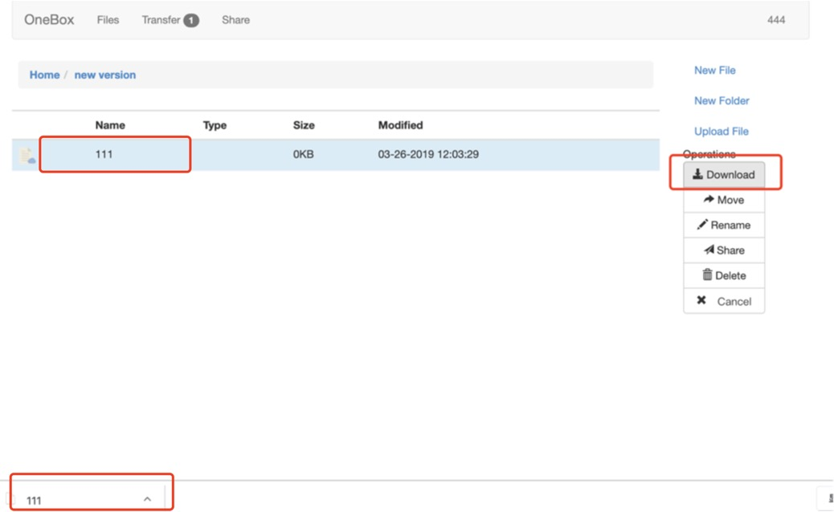

Figure 1.4 Download successful

1.4.3 Other File Operation Test

Other operations on files, creating, deleting, moving, renaming, etc. of folders or files,

1. New creation of a directory or file, as shown in Figure 1.5 and 1.6.

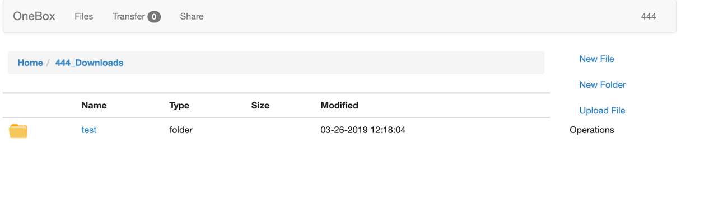

Figure 1.5 Create new folder

Figure 1.6 Successfully creating a new folder

1. Deletion of a directory or file, you can delete a single file or directory, or delete files and directories in batches, as shown in Figure 1.7 and 1.8.

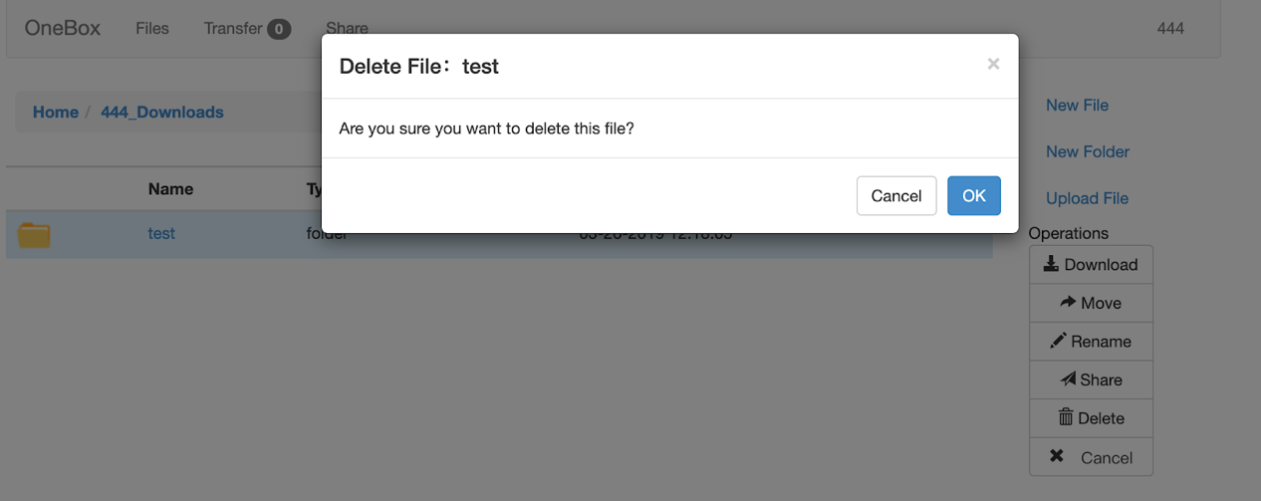

Figure 1.7 Confirm delete dialog

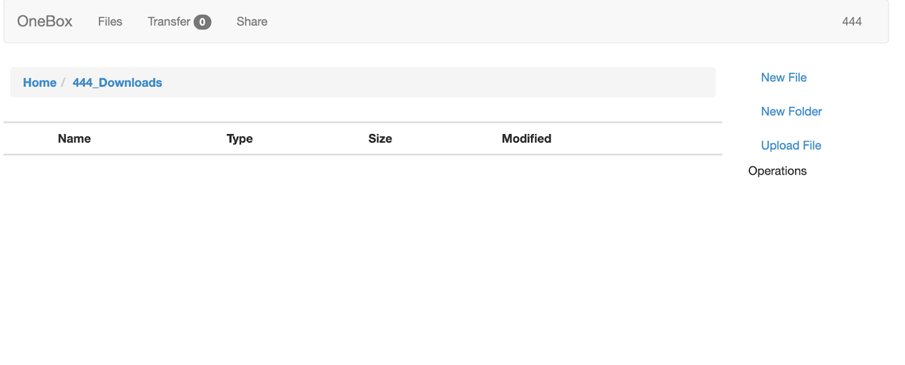

Figure 1.8 Delete successfully

(3) Copying and moving of the directory or file. When the user chooses to copy or move to another folder, a window pops up to display the user's directory tree. The user selects the directory to be copied or moved to and clicks, as shown in Figure 1.9. 图片包含 屏幕截图

Figure 1.9 Move file

Figure 1.10 Confirm rename dialog

图1.11 文件重命名成功

1.4.4 File Sharing Function Test

(2) External link sharing, select a file and click share button, and then sharing window pop-up, click to create external link to share an external link for external access to the file or directory, as shown in Figure 1.12

Figure 1.12 External chain sharing

1. External link sharing view, after entering the external link address in the browser, you can download and save to your own network disk space. If there is a password download, the password will be verified, as shown in Figure 1.12.

                                Figure 1.12 External link sharing view